**Chapter 1**

**1.1 Abstract**

There has been an astronomical increase in the number of educational institutions established especially in the last four decades all over the world. This development has brought education to the doorstep of people. Consequently it has increased knowledge and helped produce a population of enlightened citizens who can easily abide by the rules of civilized society and contribute meaningfully to the process of democratic governance. Most of the newly established educational institutions however, are using the old conventional techniques for managing their assets especially hostel facilities. This old techniques with its inherent limitations have impacted negatively on the overall organizational efficiency of this educational systems. In this paper, the development of an automated hostel accommodation management system is proposed. The codes for the automated system were developed using Java Programming Language and MySQL database was used to develop the underlying database. It also has in-built authentication algorithm for preventing unauthorized access. The developed system overcomes the drawbacks of traditional methods of hostel management; it is more user-friendly, graphical-user-interface oriented, reliable, efficient and secured with access control mechanisms.

**1.2 INTRODUCTION**

The fundamental theories of economics assert that the success of an organization is a function of how well it harnesses and optimizes the available resources (factors of production) towards achieving its organizational objectives. By resources, we mean the physical resources and conceptual resources. The physical resources are land, labor/machine, capital and entrepreneurship while the conceptual resource is information. No matter the volume of funds that might have gone into an investment, if there is no effective coordination of efforts/resources, the whole investment will end up as a colossal waste and the vision behind the efforts will not be achieved. Thus management is a major factor that determines the index of success achievable by an organization in its quest towards realizing its corporate objectives.

Research has also further revealed that it is the quality of initiative applied in management that matters.

By initiatives, we mean the scientifically proven models, theories,techniques methodology or algorithms applied in resource management. Appropriate mathematical models like queuing theory, transportation model, simplex method, scheduling algorithm etc have proved very useful when applied to resource allocation and management.

Our research work described in this write-up is narrowed down to educational institutions. In a bid to meet the challenges of teeming population in countries all over the world, government and private investors have come into the educational sector to establish institutions of higher learning. An integral part of the facilities made available in such institutions are hostel accommodation spaces for students to create an academic community which will help facilitate effective refinement and development of the students.

However, most of these hostel facilities especially in institutions in developing countries are managed with conventional manual methods and this has been impacting negatively on the effective resource utilization and overall efficiency of these academic institutions. The manual method of managing and administering hostels in institutions is obviously not effective as it is attributed to the following challenges:

* Difficulties in record management - data redundancy, difficulty in data update; difficulty in data recovery; difficulties in generating information about those students who had left the hostel, vulnerability to manipulations/human error;
* Difficulty in tracking the history of a facility – a room or chalet or building;
* Registration for hostel allocation is done manually, thus over time, handling of the paper files becomes cumbersome and untidy as the population of student increases;
* The whole exercise is time-consuming and a waste of human and material resources.

The proposed system provides solution to the problems of traditional method of managing hostel facilities. The system attempts to improve institutions’ hostel services for stakeholders - administrator, management and students of the hostel. It automates the administrative processes and reduces the stress associated with searching for information on a student in a bundle of registers. It is specially designed to centrally allocate and manage accommodation spaces in a typical student’s hostel. The students in the hostel will be recognized by their matric number supplied when registering them. The system registers and assigns a Unique Id to each room in the hostel during the point of registering the hostel. The system allows the manager to allot room to registered student within the available hostel and room. The manager can as well from the system evict a student from a particle room if violated the rule of the hostel or hostel rent due.

The system has a unique approach to tracking information and report generation which is vital in data handling. This makes the proposed system more robust, more reliable and efficient. Entire gamut of the system comprises of several modules for room allocation, student registration, hostel registration and other administrative activities. It can be well defined to track performance within the application of hostel accommodation system. The system uses one single central database to handle the complexity of student’s hostels management and all administrative functions.

The hostel management system software is user-friendly application package specifically designed to automate, coordinate and look after all the processes of managing hostel facility. It is useful especially in large educational institutions with college hostels, school hostels, and organizations. All the functions that hostel management entails can easily be managed by hostel management software.

**Chapter 2**

**2. LITERATURE REVIEW**

**2.1** In an attempt to review existing literature on this innovation - Hostel management system, we came across a number of similar products that are in use in many colleges worldwide. Some of them are described below:

College Hostel Management Software developed by Initio has six modules such as the library module, the transport module, the hostel module, the inventory/store module, the enquiry module and the visitors tracking module. It offers information on the building, rooms and students.

Microbes Hostel system is another software product that automates the hostel facility management exercise. It has several compelling features like powerful reservation management, synchronization of computers, reception and cash box administration, point of sale, accounts statistics and reports.

Loventis booking system is another innovation from Loventis systems (2005). It has features like property management system (PMS), channel manager and booking engine, plug and play. In addition,

Indocon micro engineers limited developed a hostel management software with special features such as customizing technology, revenue management, integrated web booking engine and interfaces to all booking channel.

**Chapter 3**

**3.1 System Analysis and Design**

Systems analysis is a process of collecting factual data, understanding the processes involved, identifying problems and recommending feasible suggestions for improving the functionality of the system. This involves studying the business processes, entity relationships gathering operational data, understand the information flow, finding out bottlenecks and evolving solutions for overcoming the weaknesses of the system so as to achieve the organizational goals. System Analysis also includes decoupling of complex processes that make up the entire system, identification of data store and manual processes.

System design is an attempt towards creation of a new system. This phase focuses on the detailed implementation of the system. System design has two phases: logical design and physical design.

During logical design phase, the analyst describes inputs (sources), outputs (destinations), databases (data sources) and procedures (data flows) all in a format that meets the uses requirements. The analyst also specifies the user needs and at a level that virtually determines the information flow into and out of the system and the data resources. Hence, the logical design is done through data flow diagrams and database design.

The logical design is followed by physical design or coding. Physical design produces the working system by defining the design specifications, which tell the programmers exactly what the candidate system must do. The programmers write the necessary programs that accept input from the user, perform necessary processing on accepted data through call and produce the required report on a hard copy or display it on the screen.

**3.2 Software Tool (Programming Language)**

**Java** is a general-purpose computer programming language that is concurrent, class-based, object-oriented and specifically designed to have as few implementation dependencies as possible. It is intended to let application developers "write once, run anywhere" (WORA meaning that compiled Java code can run on all platforms that support Java without the need for recompilation. Java applications are typically compiled to byte code that can run on any Java virtual machine (JVM) regardless of computer. As of 2015, Java is one of the most popular programming languages in use particularly for client-server web applications, with a reported 9 million developers Java was originally developed by James Gosling at Sun Microsystems (which has since been acquired by Oracle Corporation) and released in 1995 as a core component of Sun Microsystems' Java platform. The language derives much of its syntax from C and C++, but it has fewer low-level facilities than either of them.

The original and reference implementation Java compilers, virtual machines, and class libraries were originally released by Sun under proprietary licenses. As of May 2007, in compliance with the specifications of the Java Community Process, Sun relicensed most of its Java technologies under the GNU General Public License. Others have also developed alternative implementations of these Sun technologies, such as the GNU Compiler for Java (byte code compiler), GNU Class path (standard libraries), and Iced Tea-Web (browser plug-in for applets)

MySQL, is a database management system that combines the relational Microsoft Jet Database Engine with a graphical user interface and software-development tools. My SQL stores data in its own format based on the Access Jet Database Engine. It can also import or link directly to data stored in other applications and databases.

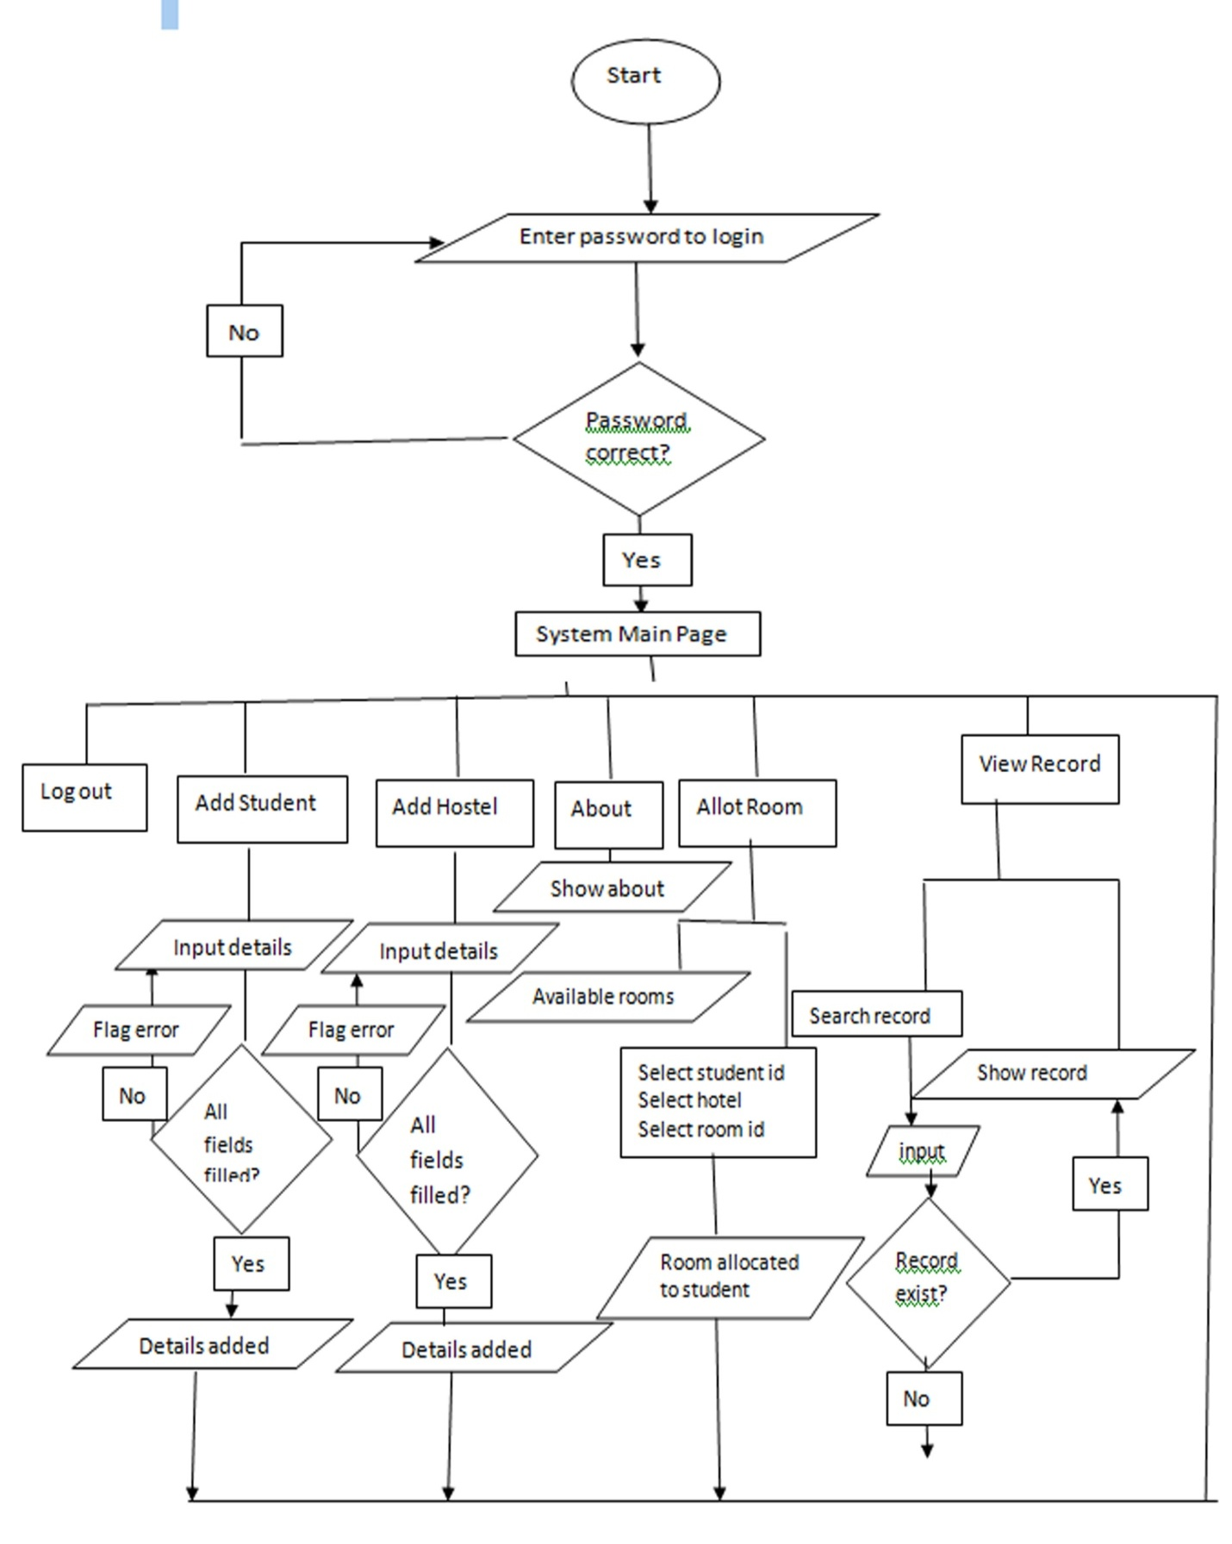**3.3 Algorithm Design (flow chart):** The step by step algorithm implementation to the system.

**3.4 Database Design and Relation**

The System has four tables

1. Students Table: the students table records all the basic information about each student with their matric no as primary key.

students (student_id, name, dept, level, sex, phone, email, pMobile, address, state, image)

1. Hostel Table: the table record information about each hostel with the number of rooms in the hostel.

hostel (hostel_id, name, address, price, description, phone, rooms)

1. Rooms Table: record for rooms available in each hostel with unique room id and hostel id as a foreign key.

rooms (room_id, hostel_id*, status)

1. 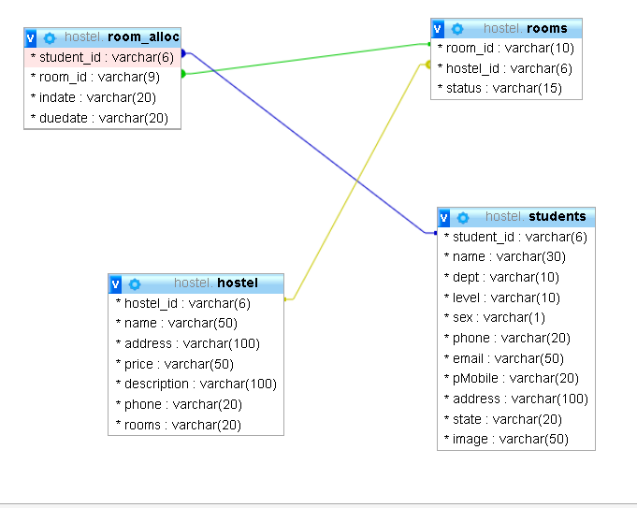Room_ alloc Table: record room allocated to each student with the date allocated and due date.

room_alloc (student_id*, room_id*, indate, dueDate)

**3.5 Modular Design**

Modular design is an approach that subdivides a system into smaller parts (modules) that can be independently created and then used in different systems to drive multiple functionalities.

**The Administrator/Manager can:**

1. Add Student to record.
2. Add hostel and rooms to manage.
3. Allot different students to the available rooms.
4. View the record of all students or search with student id or room id.
5. Evict student from room.
6. **Login Module**:

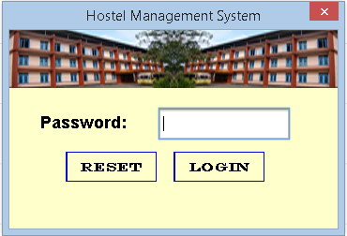

1. **Home Module**: It contains the index of all the function buttons for implementation; it comes up after the acceptance of the login details at the admin login module and after a successful operation.

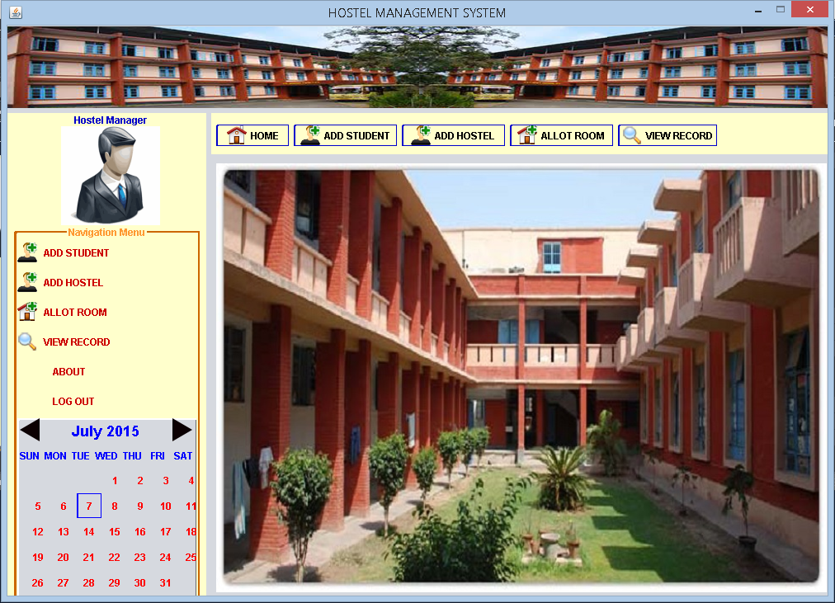

1. 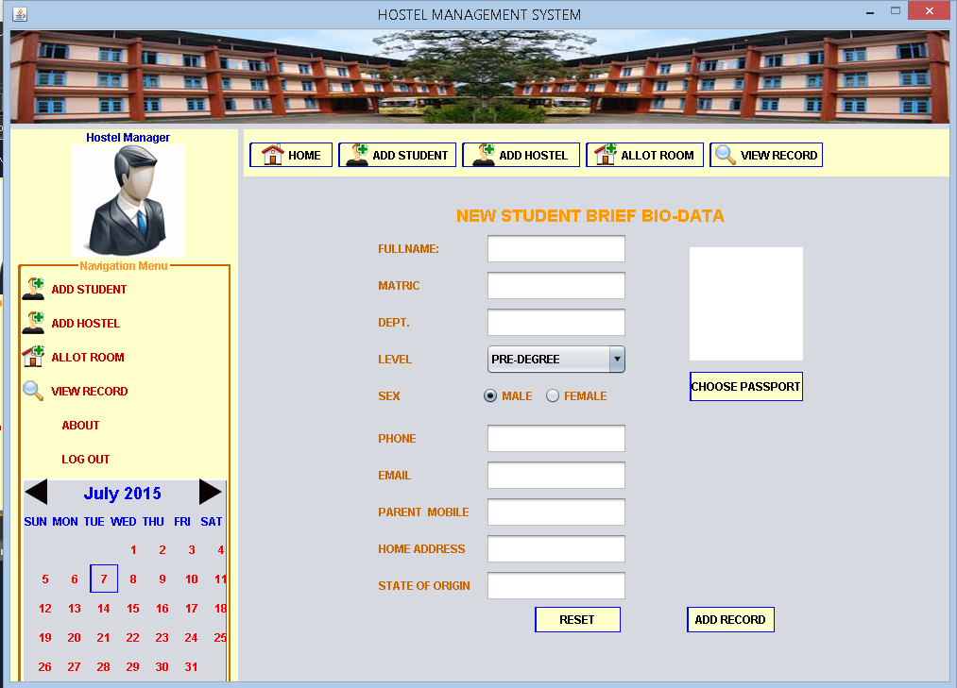**Add Student Modules**: This module allow the manager to add record to new student to the database record. The details of each student are maintained and updated regularly.
2. **Add Hostel Module:**  This is an interface that allows the manager to add new hostel to the db with the rooms available in the hostel for proper management and also show list of registered hostels with their details.

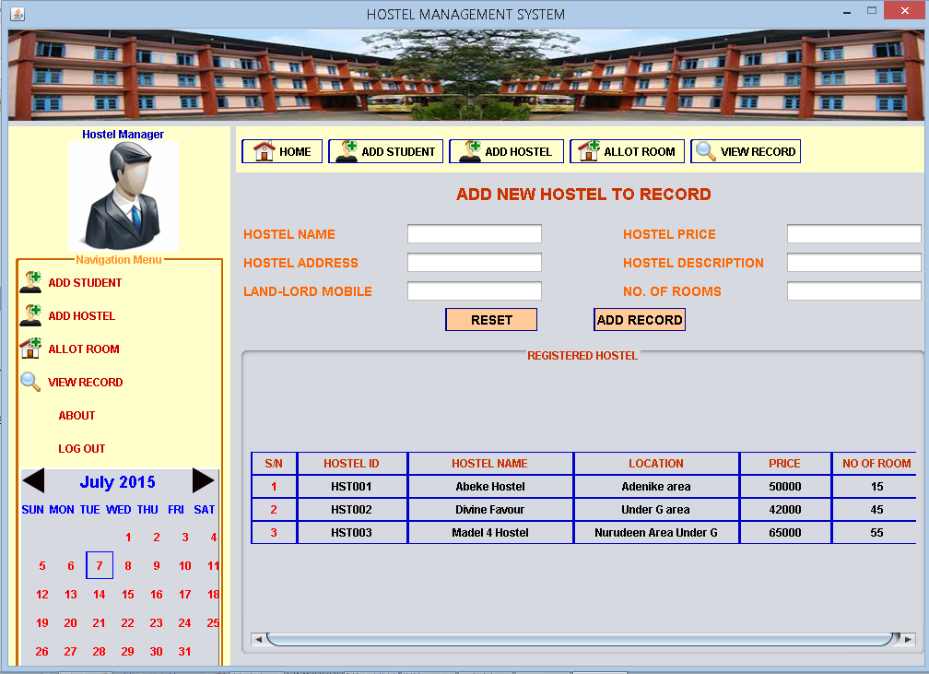

1. **Allot Room Module:** This module allow the manager to allocate rooms to students from the available hostels and rooms and also show a list of available rooms with description.

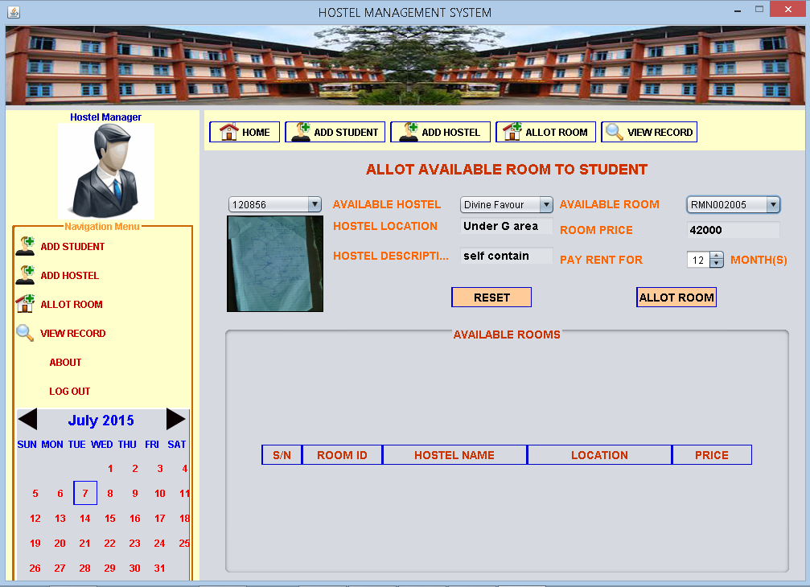

1. 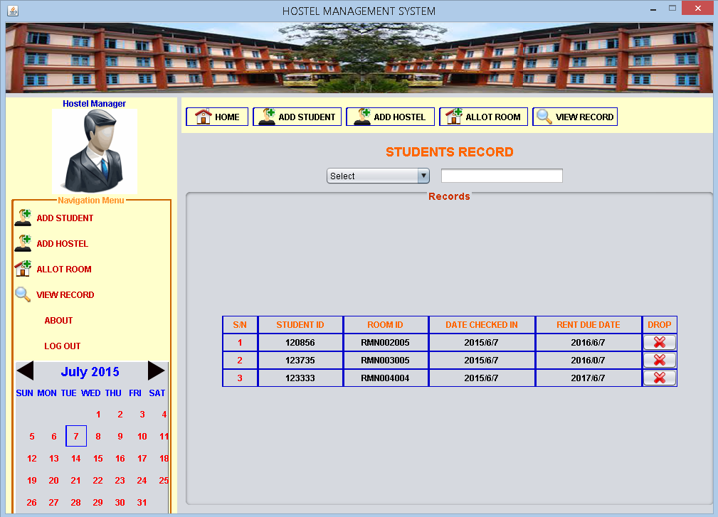**View Record Module**: This is an interface that shows the list of the each student allocated to each room, it also has an interface for searching for students via student id or room id and also allows the manager to evict student from room.
2. 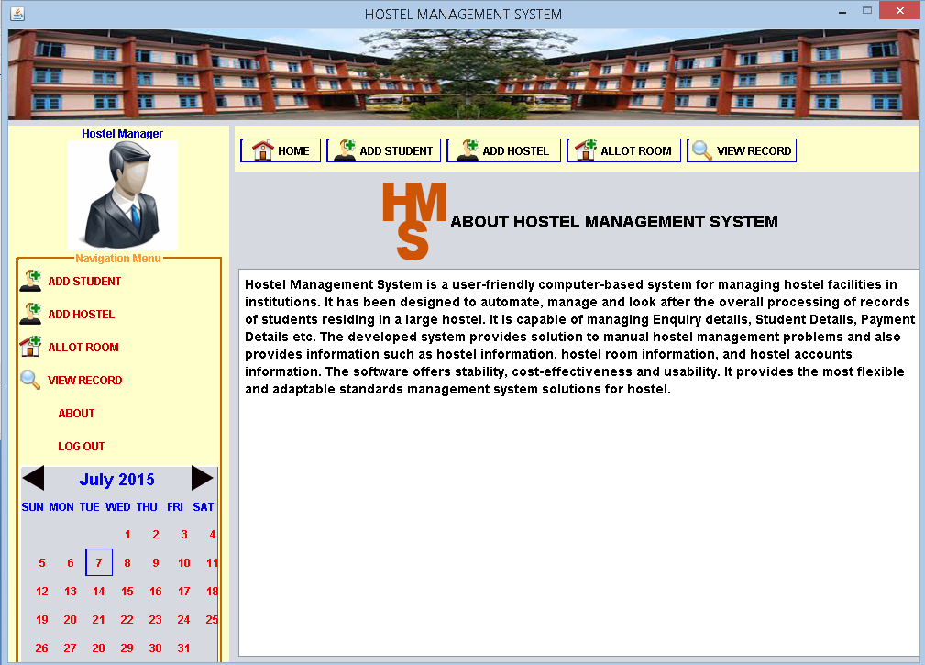**About Module**: It explains the main objective of the computerized hostel management system, and provides a user guide for the software.

**Chapter 4**

* 1. **CONCLUSION**

Hostel Management System is a user-friendly computer-based system for managing hostel facilities in institutions. It has been designed to automate, manage and look after the overall processing of records of students residing in large hostels. It is capable of managing Enquiry details, Student Details, Payment Details etc. The developed system provides solution to manual hostel management problems and also provides information such as hostel information, hostel room information, and hostel accounts information. The software offers stability, cost-effectiveness and usability. It provides the most flexible and adaptable standards management system solutions for hostel.

* 1. **REFERENCES**

[1] http://www.kassoftindia.com/Product/GeniusAcademic/hostelmgt.htm [accessed September 24, 2012]

[2] Hampton, David R. 1977. Contemporary Management, McGraw-Hill Series in Management.

[3] http://www.educationmanagementsoftware.com [accessed June 15, 2011]

[4]http://nptel.iitm.ac.in/courses/Webcourse-contents/IIScBANG/System%20Analysis%20and%20Design/pdf/Lecture_Notes/LNm5.pdf [accessed June 20, 2012]

[5] http://www.bbnisys.com/images/eschool.pdf [accessed October 10, 2012].

[6] College Hostel Management Software by Initio (2010).

[7] Loventis Booking System by Loventis Systems (2005).

[8] Indocon Hostel Management Software by Indocon Micro Engineers Limited.